Picking the Perfect Pooch

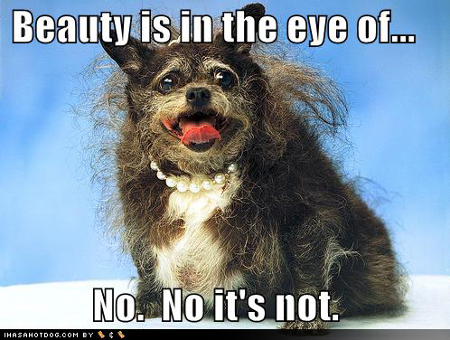

Introduction

First thing’s first: despite the title of this report, there is no such thing as a perfect pooch (just as there is no such thing as a perfect human). The closest you can come to picking the perfect pooch is to pick one that’s best for you and your family.
You know what’s weird? Dog owners all believe their dog’s personality is distinct and unique. Even if they own two dogs of the same breed, perhaps even from the same litter, they’ll say each dog has a personality all his own. And they’ll be right. And yet many of those same people believe that dog personalities are determined by breed. They’ll say things like “Golden Retrievers don’t bite,” or “Pit Bulls are vicious.” And they’ll be wrong. A dog’s personality, like that of a child, is determined more by “nurture” than “nature.” Depending on how he’s raised, a Golden Retriever will bite and be vicious; a Pit Bull will be a gentle coward.
It is true that dogs of a certain breed may share some behavioral characteristics (e.g., most Labrador Retrievers enjoy swimming and are crazy about fetching a ball). There are exceptions to every rule, but knowing behavioral (as well as physical) characteristics will help you to decide on a dog that will likely be a good fit for you and your lifestyle. We’ll cover that later in this report.
But looking beyond the breed characteristics and picking a dog based on his individual personality is a very important—yet often overlooked—step in finding a dog that’s best for you and your family.
Keep an open mind about what type of pooch to pick until after you’ve done your homework. You and your soon-to-be best friend will be much happier with the results.

First step: read the rest of this report!

Puppy or Adult?

Should you get a puppy or an adult dog? This is the first decision you need to make before picking a pooch. Please give this some serious thought. If you do, your final decision may surprise you.

Most people don’t even think about the adult dog option—they just go out and get a puppy. They’re so cute! Adorable! Fun! Just the word “puppy” makes most people feel all warm and fuzzy inside.
But perhaps you should at least consider the benefits of an adult dog before making your decision:
- The habits, manners, and temperament of an adult dog (at least two years old) are already established and easy for you to evaluate. Most dog rescue groups, shelters, adoption services, etc., will allow you to take a dog on a trial basis. You can take him home for a few days to see if his personality is compatible with you, your family, your other pets—in other words, you can find out if the dog fits what you’re looking for a in a new furry companion. If not, you can usually take him back. With a puppy, on the other hand, you won’t necessarily know what kind of dog he will turn out to be, because this will depend very much on you and the time you spend with him.
- Adult dogs typically require less care, attention and training than puppies. An adult dog doesn’t need to go to the bathroom as often as a puppy. They are usually housetrained, and often know the difference between a chew toy and a your favorite pair of shoes. An adopted adult dog may be an ideal “out of the box” companion that is so well trained, affectionate and “perfect” that you’ll wonder how anyone could give him up. But there is the possibility of the other extreme, as well. Each dog is unique. (Hence the importance of the trial adoption period.)
- Adult dogs are less likely to be adopted from shelters than puppies. If you want to rescue a dog, picking an older one is more likely to save a life.
The key to finding a good adult dog is to take plenty of time to evaluate his habits, behavior, and personality. Proper training can correct many bad habits and teach good ones (yes, you certainly can teach an old dog new tricks!); but not all behavioral problems can be overcome.
A puppy, on the other hand, is like a lump of clay waiting to be molded by you. You can raise him to be your ideal companion. This, of course, presumes you know how to train a dog properly and have the time—and the desire—to do so. But because you’re reading this report and have subscribed to the Happy Mutt Training System, we know you’re one of those rare humans who realize what’s involved and is willing to go through it anyway—and that whatever pooch you bring home is going to be one lucky, well-trained, well-adjusted dog!
Keep this in mind: An adorable puppy will become an adolescent dog with a few months; that adolescent will quickly become an adult dog that can live from 10 to 20 years. So when considering a puppy, put a lot of thought into the grown dog it will become, and the long-term commitment you will make.
All adult dogs were once adorable puppies, and all adorable puppies will grow into adult dogs.
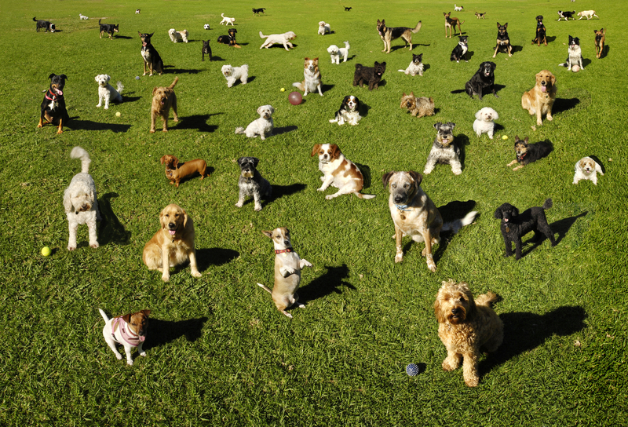
What Kind of Dog?
Mixed-Breed or Pure-Breed?
After deciding to get a puppy or adult dog, the next question is: What kind of dog is best—mixed-breed (mutt) or pure-breed? There are fans on both sides of this question who would never consider owning the “other” choice. Then there are people who just want a great companion and don’t care whether he’s a mutt or an AKC champion.
[Note: We use the term “mutt” with affection. We have a warm spot in our heart for mutts. But we love all kinds of dogs!]
As with the puppy or adult dog decision, there are pros and cons to both mutt and pure-breed options.
Pure-breed puppies are more predictable in terms of behavioral and physical characteristics. In many cases before picking a pure-breed puppy, you can check out the appearance, friendliness, basic manners, and general health of his parents. Sometimes too much breeding/inbreeding, or breeding to achieve a desirable physical characteristic (such as the flattened nose of a Pug), can create health problems. Pure-breed dogs can be expensive. Depending on the breed, a pure-breed puppy will typically cost several hundred dollars.
A mutt, on the other hand, is pretty much a one-of-a-kind dog. If you’re adopting a mutt puppy from a friend, you might see what the mother is like, but the father is often a total mystery. If you adopt from a shelter, you can only guess about both parents. Mutts generally have fewer health problems and tend to live longer than pure-breed dogs. And mutt puppies are much cheaper (often free).
You cannot simply select the "perfect" breed or the "perfect" individual puppy and have him automatically grow up to be a "perfect" adult dog.
Any puppy (mutt or pure-breed) can become a wonderful companion if properly raised and trained. Conversely, any puppy can become a canine nightmare if not properly raised and trained.
Regardless of pedigree (or lack thereof), you should pick a pooch that is best suited to you and your lifestyle.

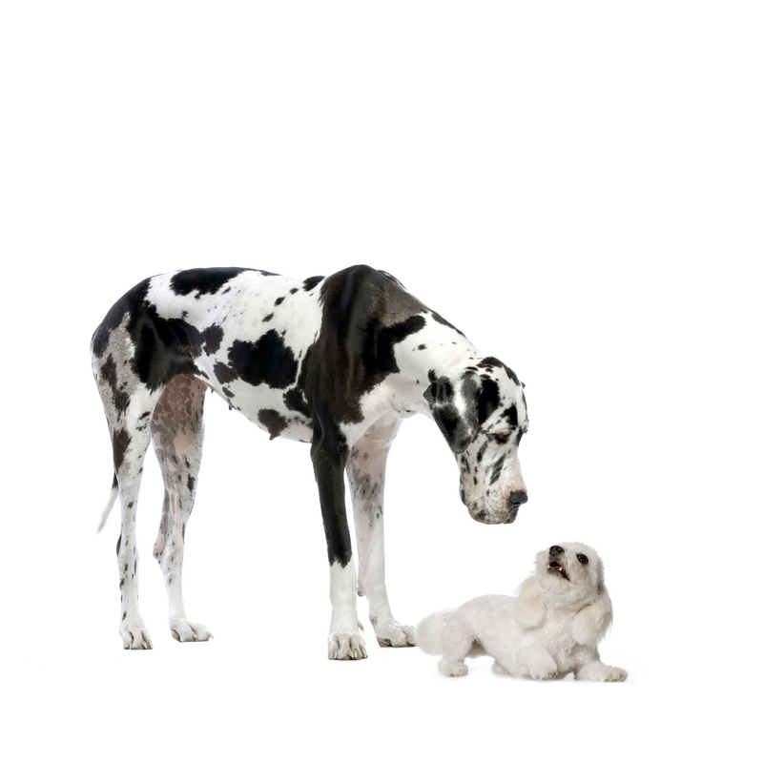
Big or Small?
Whether you want a mutt or pure-breed, the next thing you should think about is the size of the dog.
If you live in an apartment, you may think it’s best to limit your pooch possibilities to small dogs. But you don’t have to. Large dogs can make wonderful apartment companions as long as they receive regular exercise during walks or dog park visits. Large dogs are often calmer and quieter than small dogs (less barking for neighbors to complain about). Dogs of any size will make great apartment pets as long as they are properly trained.
If you have small children, would a small dog be better? Not necessarily. Any dog, regardless of size or breed, may be frightened and irritated by children. A dog that feels threatened is more likely to bite. Of course, the bite of a Chihuahua will be less severe than that of a Rottweiler. Dogs of any size can make good companions for children if they are properly trained and socialized around children (but also make sure your children are taught how to act around dogs).
Small dogs eat less (so are cheaper to feed); and you’ll have smaller piles of poop to clean up, of course. They can be easier to control (they are not physically able to drag you down the street during your walk). But again, proper training will enable you to control any dog of any size.
Do Breed Research
If you’ve decided on a pure-breed dog of a particular size, it’s time to do specific research and consider behavioral traits as well as physical ones. If you pick a pure-breed pooch without doing your homework, you may be in for some surprises.
For example, Border Collies are very smart dogs, so you might think this would be a great choice. But super-smart dogs actually require more attention and care than average-intelligence dogs. They need mental exercise as well as physical exercise. Like bright students, they tend to get bored easily—and a bored dog is not a good thing.
If you find a particular breed of dog appealing, get information about it from appropriate resources:
- Ask a veterinarian if the breed is prone to any health issues.
- Get “reviews” from people who actually own the breed. Go online. The Internet makes research easy. Just do a search for the breed and you’ll find several web sites. Don’t limit your reading to just one site; pay particular attention to comments made in online discussion forums (by owners and trainers as well as breeders). Look for tendencies and traits that you do not want, such as aggressiveness toward other dogs. Get several opinions. People who complain about behavioral problems—such as a Schnauzer that barks too much or a Chihuahua that still pees in the house at two years old—may not have trained them properly.
Even after compiling the results of your research, remember that every dog is different. His behavior will mostly be the result of genetics and how he’s raised. And don’t forget personality. Two sibling pure-breed pups raised in the same way by the same person may have totally different personalities.
Even the best breeder cannot accurately predict how a puppy will turn out.
But there are things you can do to increase your odds of finding a great dog.
Picking a Pooch

Most people pick dogs based on physical characteristics. A particular color, length of hair, type of ears, etc. But just as with people, you should look beyond the “pretty face.” The plain black pooch that others ignore might be the best choice.
You want to a dog that likes you, is friendly (not shy or scared), and doesn’t mind being handled.
Don’t pick a puppy that is less than eight weeks old. Some breeders will want you to reserve a puppy at a younger age. That benefits them, not you (and not the puppy). A very young puppy hasn’t yet developed a personality. You’ll have no way of knowing whether such a young puppy will be timid or friendly, for instance. And this is definitely something you’ll want to know, especially if you’re paying big bucks for a pup that you’ll be sharing your life with for several years!
If you’re getting a puppy from a breeder, be sure to “meet” the pup’s parents. Pay close attention to their behavior. Their behavior may give you a clue to the eventual disposition of the puppy. Don’t get a puppy from parent dogs who aren’t friendly.
Look for puppies raised indoors around people instead of in an outdoor kennel. You want a puppy to share your home; so look for a puppy that has been raised in a home.
If you’re getting an adult dog and can talk to the person giving him up, ask specific questions about its behavior. Avoid vague questions like: Is he friendly? Ask these instead: Does he like to be groomed and handled? Can you trim his nails? What happens if you take away his favorite toy? Is he good around other dogs (familiar and unfamiliar ones)? How does he react to strangers? Does he bark a lot at visitors? Has he ever growled, shown his teeth, or bitten anyone?
In Summary
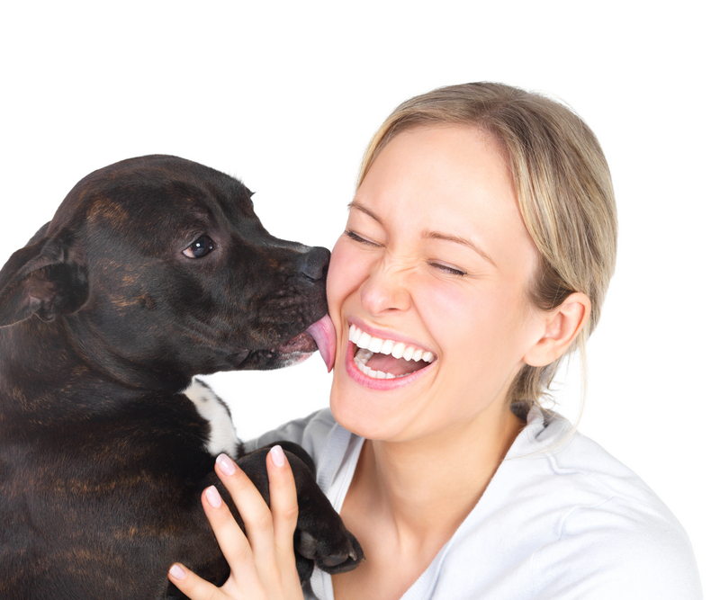
Regardless of the many reasons for picking a particular pooch—whether pedigree, size, cuteness, or other traits you find appealing—the success of the relationship between you and your new friend will ultimately depend on how you raise and train him.

